Dog Adoption Application Form
Dog Act 1976
ENF/6

Applicant Details

Mr/Mrs/Miss/Ms | Surname: |  |  |  |  | Given Name:
Residential address:
Suburb: |  |  |  | Postcode: |  | Contact number/s:
Postal address (if different):
Date of birth: |  | Occupation:
Email address:
Residence Details
Are there any other adults living with you? |  |  |  |  |  |  | Yes |  | No
If yes, what are their age and occupation?

Type of home | Standalone Home |  | Townhouse |  | Duplex |  |  | Rural
How many hours per day (Mon-Fri) will the dog be without human company?

How many hours per day (Sat-Sun) will the dog be without human company?

What areas of the house/garden will the dog have access to when family is home?

What areas of the house/garden will the dog have access to when home alone?

Where will the dog sleep at night?

Do you have children living with you or visiting regularly? If yes, what are their ages?
What is the minimum height and material of your fencing and gates?

Dog Owner Capabilities
Have you owned a dog before? | Yes | No
Have you previously adopted any animals? If so where from? | Yes | 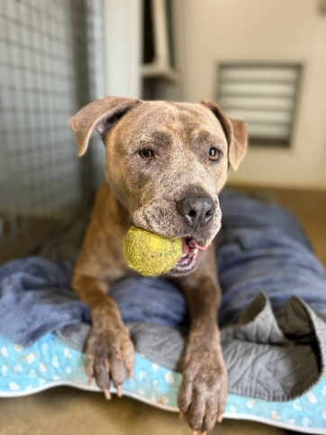  No
Do you currently have any other dogs living with you? | Yes | No
If yes, please specify how many, name breed and gender:

Are your dog/s sterilised? |  |  |  | Yes | No
Are your dog/s vaccinated? |  |  |  | Yes | No
Are your dog/s microchipped? |  |  |  | Yes | No
Are your dog/s registered? |  |  |  | Yes | No
Have there ever been any issues between your current dog/s and/or other dogs? If yes provide details:

Do you have any other pets or livestock at home? |  |  |  | Yes | No

Please note: The Shire of Augusta Margaret River has a duty of care for every dog that comes into its possession and therefore tries to ensure that all dogs are re-homed to the most suitable place. Only suitable applicants will be contacted. Please also consider one of the many other places dogs are available for adoption within WA. We appreciate your support and understanding about our adoption process and policies.

Declaration – I declare that:
I am over 18 years of age; the information provided is true and correct to the best of my knowledge; I have not been convicted of an offence under the Dog Act 1976, Cat Act 2011 or Animal Welfare Act 2022 within the past 3 years.
Signed: |  | Date:
Office Use Only
CSO Signature: | Date: |  | Record No:

Please send completed application form to rangersteam@amrshire.wa.gov.au.

