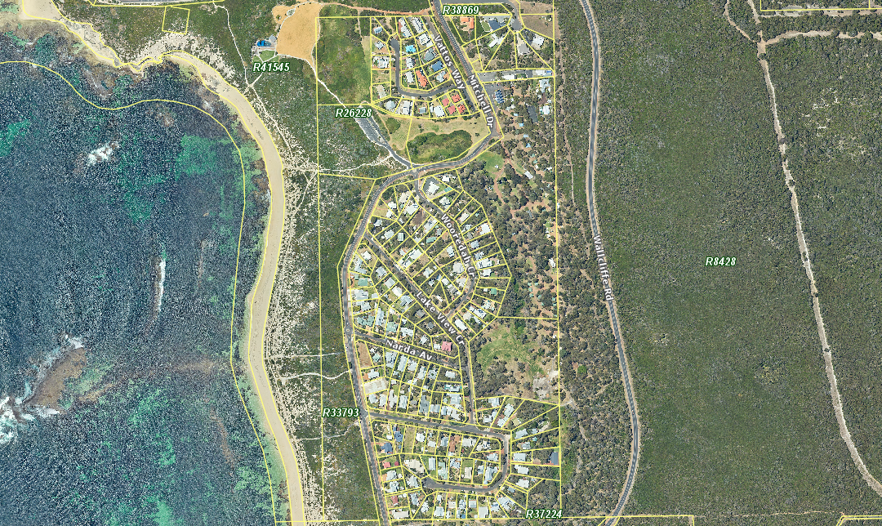
 | The Shire of Augusta-Margaret River does not warrant the accuracy of information in this publication and any person using or relying upon such information does so on the basis that the Shire of Augusta-Margaret River shall bear no responsibility or liability whatsoever for any errors, faults, defects or omissions in the information. | Current Dog Exercise Area  Prevelly Beach  2022 Review | Monday, 21 November 2022
 |  |  | 1:5678

